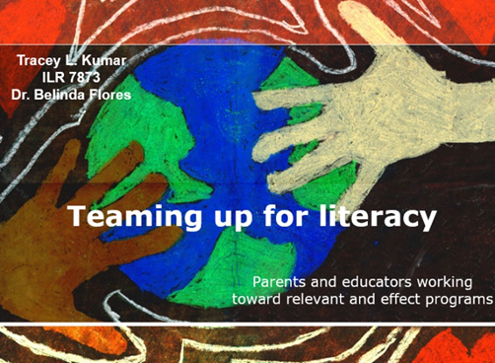

ILR 7873: Survey Research

Course Instructor
Dr. Belinda Bustos Flores, Professor
Dept. of Interdisciplinary Learning & Teaching
Ph.D. in Curriculum & Instruction--Multilingual Studies
Course Description
Exploration of survey research methodology, development of survey, questionnaire, or inventory, including item construction. Discussion and application of sampling and data collection procedures. Coding data, piloting instrument, and conducting reliability and validity of instrument. Conducting data analysis procedures using SPSS to respond to research question(s) will include application of descriptive and inferential statistics.
Course Assignments
1. Excerpts from ILR 7873 Research Proposal
Excerpt 1. Once family educators have gained adequate knowledge related to the practices and traditions of the target group, they will be better equipped to design culturally relevant programs. To that end, educators must take care to select materials and activities that address the languages and cultures of the participants (Wiley & Ebata, 2004; Yokota et al., 2008). More specifically, educators should include books and materials in participants’ home language and incorporate stories that mirror the beliefs and views of the target group. While all individuals will benefit from opportunities to read multicultural literature, those represented in the stories are likely to receive the greatest reward. As Yokota et al. (2008) point out, “Students from the cultures represented feel a sense of self-esteem when they see themselves reflected in the literature” (p. 180).
Excerpt 2.
To elucidate the meaning of home literacy practices, this study will look to the Opportunities Recognition Interaction Modeling (ORIM) framework (Hannon, 1995), which details various forms instructional support, which parents can provide for children at home. The framework comprises the following four strands of literacy-related activities:
- Opportunities—Providing books, writing utensils, and workspace;
- Recognition—Offering praise for literacy accomplishments;
- Interaction—Engaging in literacy events with children; and
- Modeling—Showing them how to read or write by exhibiting the behavior.
It also includes four different ways that each type of activity can be carried out: books, environmental print, written language, and oral interaction (Hannon, 1995; Morgan, Nutbrown, & Hannon, 2009).
2. Examples: Works Read & Cited
Cassidy, J., García, R., Tejeda-Delgado, C., Garrett, S.D., Martínez-García, C., & Hinojosa, R.V. (2004). A learner-centered family literacy project for Latino parents and caregivers. Journal of Adolescent and Adult Literacy, 47, 478-488.
Elias, G., Hay, I., Homel, R, Freiburg, K., Prothero, C., & Ernst, R. (2006). Enhancing parent-child reading in a disadvantaged community. Australian Journal of Early Childhood, 31, 20-25.
Neumann, M. M. & Neumann, D.L. (2009). More than just storybooks: Promoting emergent literacy skills in the home. Childhood Education, 85(4), 257-259.
Reyes, L. V. & Torres, M. N. (2007) Decolonizing family literacy in a culture circle: Reinventing the family literacy educator’s role. Journal of Early Childhood Literacy, 7, 73-94.
Schmidt, P. R. (1999). Know thyself and understand others. Language Arts, 76, 332-340.
Yokota, J., Teale, W. H., & Quiroga, R. E. (2008). Literacy development for culturally diverse students. In S. B. Wepner & D. S. Strickland (Eds.), The administration and supervision of reading programs (4th ed.), New York: Teachers College Press.
3. Sample Items: Original Q-HELP Survey
Students in ILR 7873 were required to develop a survey relevant to their area of specialization. I used the ORIM Framework to develop a survey pertinent to the home literacy practices of adults with young children. The survey asked participants to rate how frequently they utilized certain home literacy practices. A few examples include:
- Let your child see you reading books or magazines?
- Praised your child for writing words or sentences on his or her level?
- Given your child household items (e.g., cereal boxes, packages, mail) to practice reading?
- Practiced writing (words, sentences, etc.) with your child?
- Read books or magazines with your child?
4. Description: Presentation of Research Proposal
Students were also required to present their research proposal to their classmates at the end of the semester. The title slide of the accompanying Power Point, which included 11 slides, appears at the top of this page. In my presentation, I addressed literacy programs for parents, the ORIM framework on which my survey was based, and results from the pilot study with a diverse group of 26 adults.

